Progress Toward a GW-BASIC Front-End

Samuel Caldwell
Champlain College
CSCI-430: Compilers
Dr. Kenneth Revett
4 November 2025

Progress Toward a GW-BASIC Front-End
This student’s father once said “Boy, you could tear apart an anvil with a feather.” His other statement aligned with this project was “Boy, you’d overcomplicate ice cream.” This student has yet to discover how one might overcomplicate ice cream, which is probably why he realizes he is probably overcomplicating this compiler project. Nonetheless, this report describes the changes made to the project to implement a recursive-descent parser, improve semantic analysis and employ LLVM-style RTTI for the AST.

Quality Controls
For this report, the student presents the ‘week2’ branch of the GitHub repository (https://github.com/sam-caldwell/csci-430/tree/week2). Along with the week’s required goals, this branch also introduces a GitHub Actions CI pipeline for automated testing of the project against macOS and Ubuntu Linux. At the end of week1, this student had implemented a rudimentary GW-BASIC compiler and a number of .bas demo programs. This has been extended to include more of the GW-BASIC language, a work which remains in progress, maintaining a minimum 90% test coverage, including unit tests, integration tests and end-to-end tests. Test-driven development has allowed the student to increase development velocity while guarding against regressions, especially when it came to improving semantic analysis.

Semantic Analysis and AST Improvements
While this student started with a recursive-descent parser (week1), this week (week2) required a significant refactor of the parser and AST to implement LLVM-style RTTI as well as to make the code itself more DRY (Don’t Repeat Yourself). We did this through templates in the AST, starting with RTTI.h:
Figure 1: RTTI.h Template
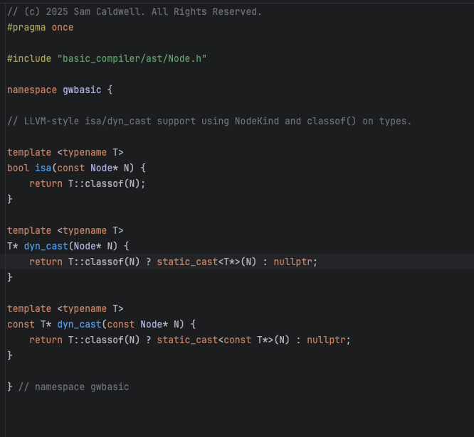
This approach allowed the AST to become more extensible with less effort through reusable code such as the ASTLeaf, etc.:
Figure 2: NodeTemplate.h
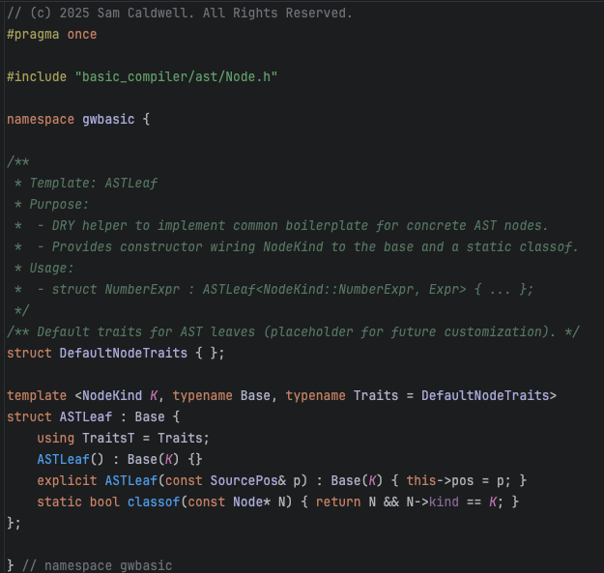
This week’s objectives also required creating a dedicated SemanticAnalyzer class to grow past the minimal functionality of week1. However, further refactoring is necessary to reduce the cognitive complexity of functions like SemanticAnalyzer::analyzeStmt().
For improved type semantics, we have added several language keywords and operators to allow type definitions beyond the default (e.g., DEFINT, DEFSNG, DEFDBL, DEFSTR, $, !, and %.). To perform end-to-end tests of our type operations, we created several new demo programs under demos/*.bas:
Figure 3: Demo Programs for Type Checking Semantics
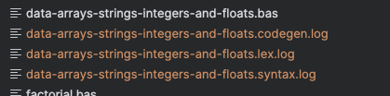

Scope Handling in GW-BASIC
Everything in GW-BASIC is global (by default). Variables (including arrays) live in a single program-wide namespace Microsoft. (1986). GOSUB subroutines do not create locals; they see and modify the same variables as the caller. DEF FN has local parameters, but only there. Single-line user-defined functions (DEF FN=…) treat their formal arguments as local names that don’t affect program variables of the same name; any other identifiers in the expression refer to the current program-global values Microsoft. (n.d.). The only other scope boundary in GW-BASIC is when using RUN/CHAIN to transfer execution control to a sub program. In this case, unless COMMON or ALL are used, the program will convey none of its global state to the sub program.
Thus, the scoping challenge in GW-BASIC required implementation of the DEF FN, RUN, CHAIN, MERGE, COMMON and ALL features of the language. Integration and end-to-end (e2e) tests validate operation of this scope requirement, such as tests which use the demos/*.bas programs:
Figure 4: Demo BASIC programs using CHAIN
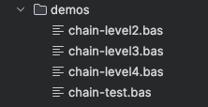
Figure 5: Other demo programs test RUN/COMMON/ALL
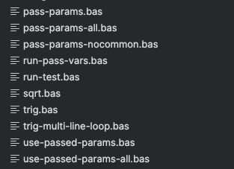
Lifetime policies in the Code Generator were the hardest part of implementing RUN, CLEAR, and CHAIN. This revealed a hidden scope problem in GW-BASIC. Executing CLEAR, for example, should only affect the scope of the program where the CLEAR is invoked and not leak beyond that boundary to a parent program or sub program. Unit and end-to-end tests should catch such a leak. This includes demos/run-pass-vars.bas:
Figure 6: run-pass-vars.bas
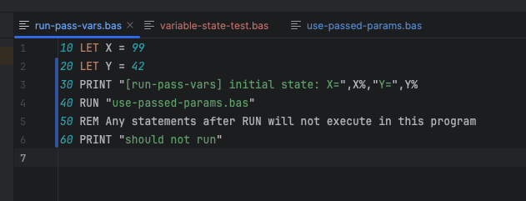
Likewise, lifetime policies in the code generator became a problem for the CHAIN command, where nostalgia dissipates and the ugly reality of GW-BASIC comes back as a nightmare:
Figure 7: GW-BASIC CHAIN Examples
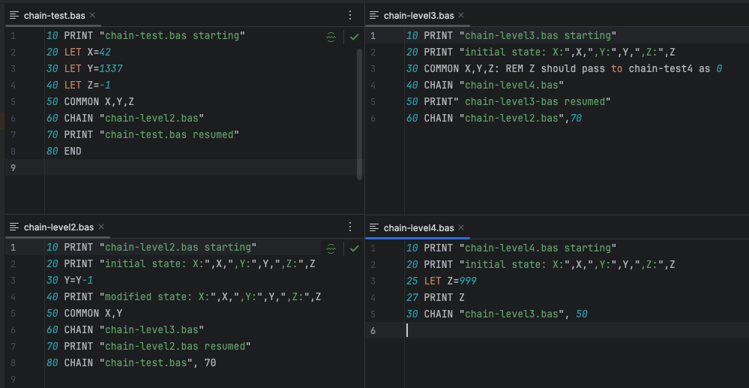
The above CHAIN code caused the compiler to become stuck in a loop, which was resolved by adding loop detection. This was done by adding a map keyed by canonical file path. Before following CHAIN/RUN to another file, they check previously imported and only parse/push if the target hasn’t been seen. We also use an explicit LIFO stack of frames so we can return to a the outer import scope once we complete each CHAIN/RUN path, but previously imported paths are now protected from being pushed to this stack because we check the map first.

References
Microsoft. (1986). Microsoft GW-BASIC interpreter: User’s reference. (Doc. 410130013-320-R01-0686). https://bitsavers.informatik.uni-stuttgart.de/pdf/microsoft/gw-basic/410130013-320-R01-0686_Microsoft_GW-BASIC_Interpreter_Users_Reference_1986.pdf. bitsavers.informatik.uni-stuttgart.de
Microsoft. (1987). GW-BASIC User’s Manual. https://ia601702.us.archive.org/13/items/GWBASICUsersManual/GWBASIC%20User%27s%20Manual.pdf ia601702.us.archive.org
Microsoft. (n.d.). GW-BASIC User’s Guide [online mirror: DEF FN / CLEAR / COMMON / CHAIN / NEW]. https://www.antonis.de/qbebooks/gwbasman/

